Biology AEBY
Task 13

Multicellular Organisms

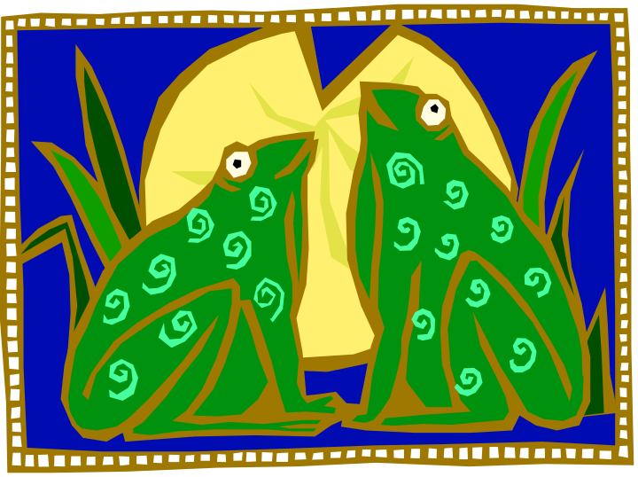Total : 30 marks.
Weighting 5%

Part A: Multichoice Section

- During respiration air moves into the lungs. This happens when

- there is downward movement of the diaphragm and an upward movement of the ribs
- the outer intercostal and diaphragm muscle relaxes
- the internal volume of the thoracic cavity decreases
- the internal pressure of the thoracic cavity increases

- Which of the following is true of gaseous exchange through the wall of the alveoli?

- diffusion of carbon dioxide occurs at the same rate in both directions
- diffusion of oxygen occurs at the same rate in both directions
- diffusion of oxygen is from alveoli to the blood capillaries
- diffusion of carbon dioxide is from the alveoli to the blood capillaries

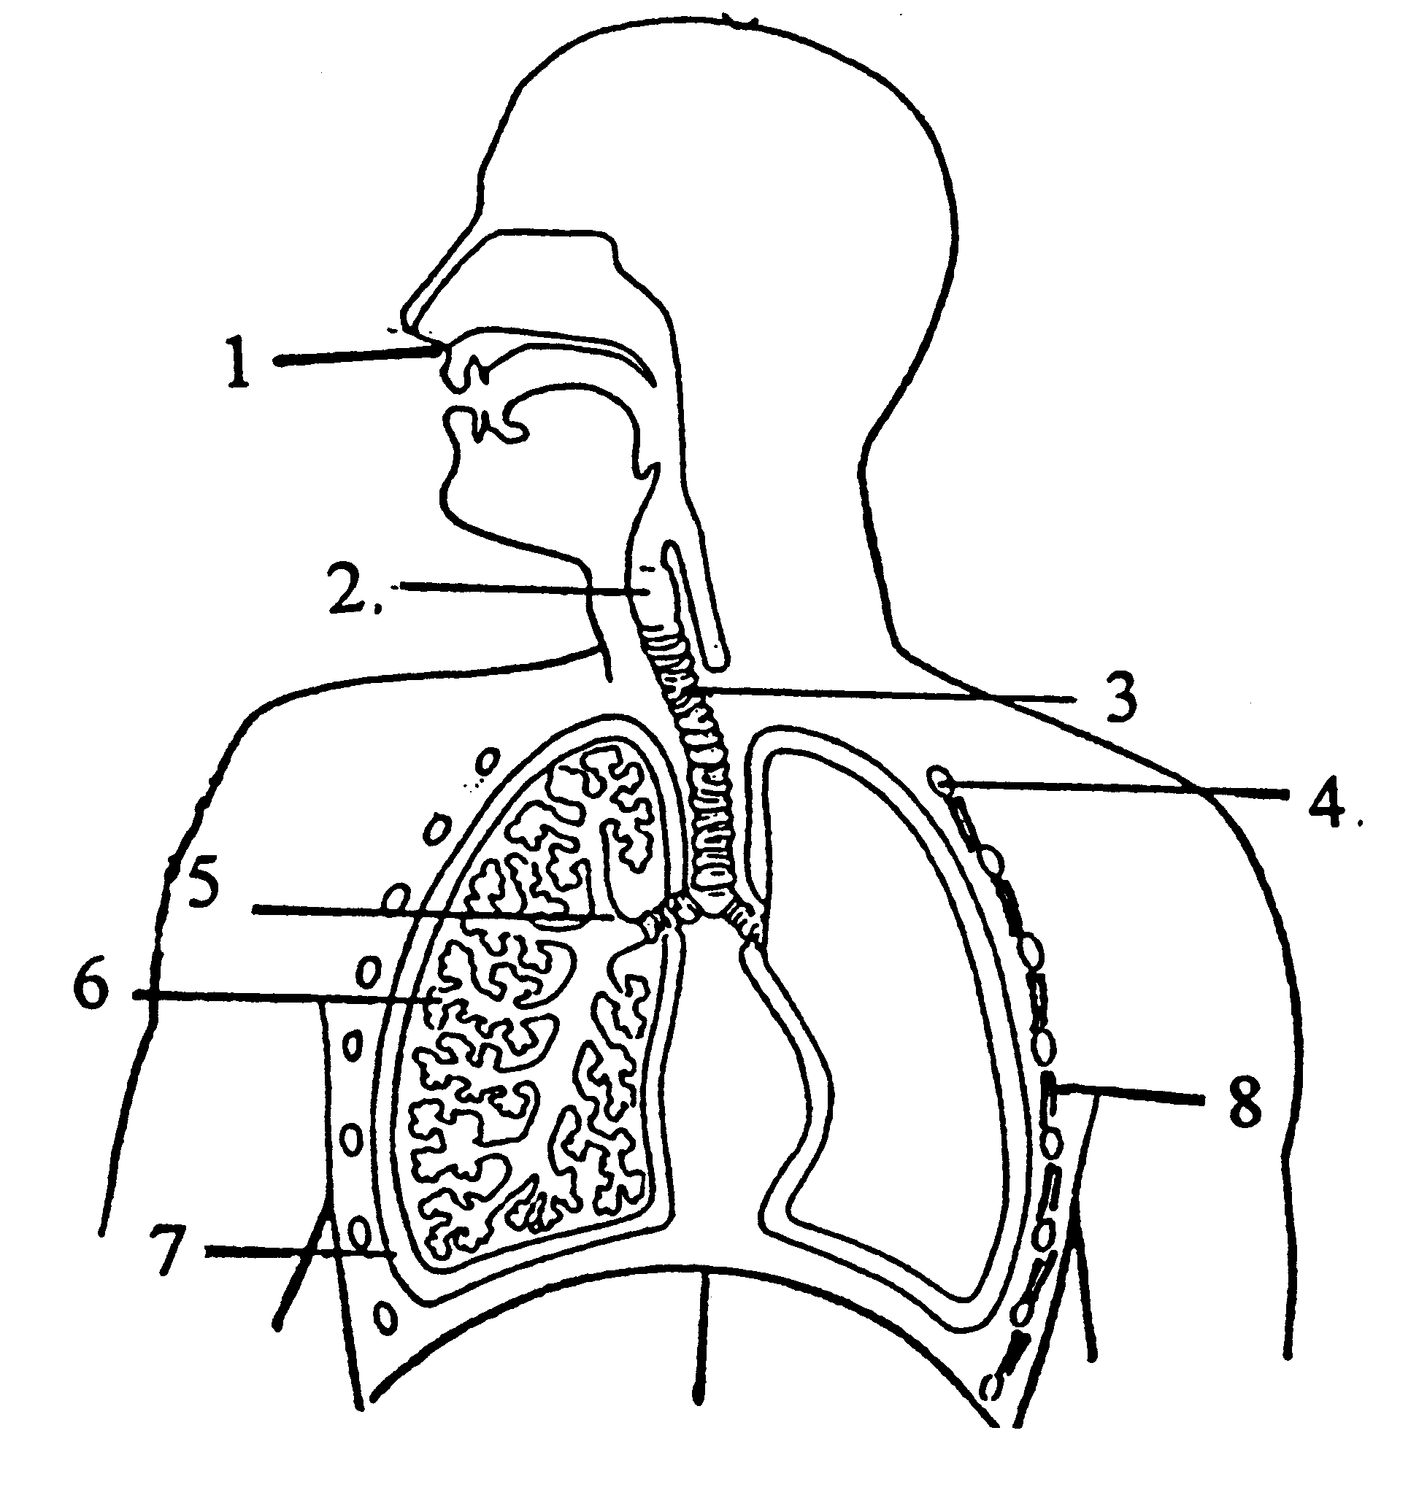
- The structures labelled above as 3,4 and 5 are in order the

- ribs, pleura, alveoli
- ribs, trachea, bronchus
- trachea, ribs, bronchus
- alveoli, intercostal muscles, pleura

- The function of the structure labelled 1 with respect to breathing is to

- direct air into the trachea
- warm, moisten and clean air
- allow you to smell
- trap dirt in the hairs inside it

- Which of the following statements is false concerning the right atrium?

- it receives venous blood through three openings
- when it contracts it empties into the ventricle across the tricuspid valve
- it receives blood from the body
- it is the thickest part of the heart

- Which of the following are involved in pulmonary circulation?

- right ventricle,pulmonary trunk,left atrium
- superior vena cava,right atrium,right ventricle
- left ventricle,aorta,pulmonary trunk
- right atrium,right ventricle,left atrium

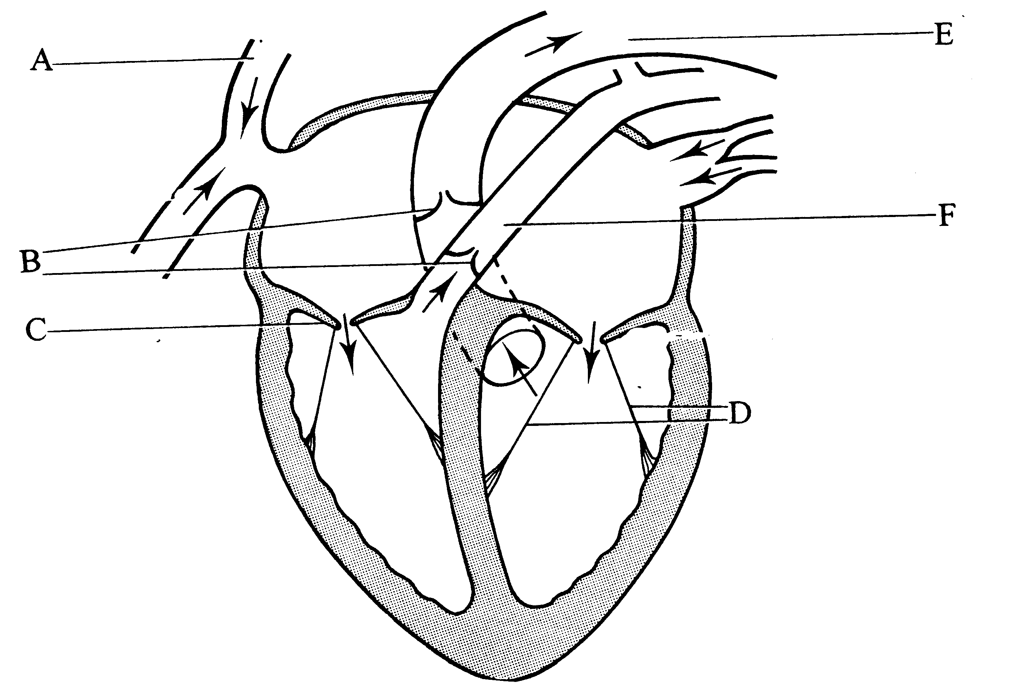
- The part of the heart labelled A is the

- aorta
- superior vena cave
- chordae tendineae
- left atrium

- What is the function of the structure labelled F?

- to carry blood from the body into the right atrium
- to carry blood from the right ventricle to the lungs
- to carry blood from the lungs to the right ventricle
- to carry blood from the body into the left atrium

A student made microscope slides of cross sections of the leaves of plants from two different

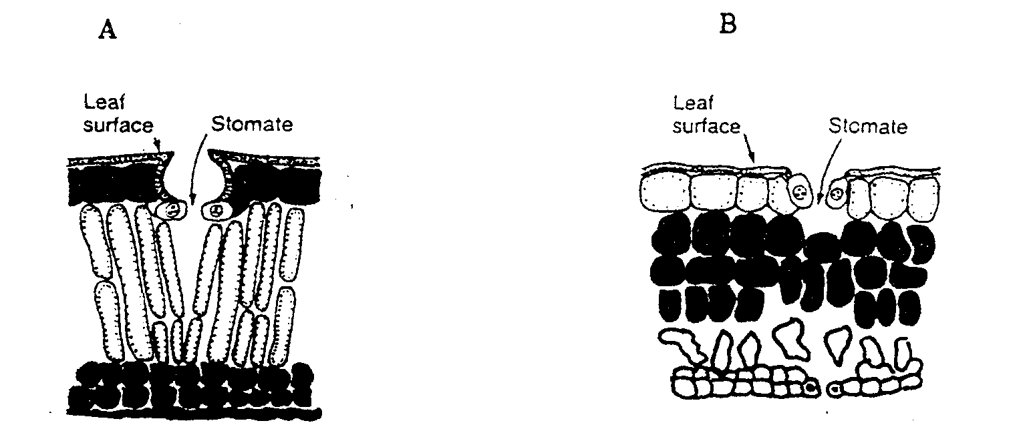

- Which of the following statements about the leaves of these two plants is true.

(a) A is adapted to a hot, dry environment due to the sunken stomata and thickened cuticle.
(b) B is adapted to a watery environment as it has large air spaces and few stomata.
(c) A would be found in shady cool environments due to the thickened
palisade mesophyll layer.
(d) Neither of these two plants are adapted to hot dry conditions as they possess stomata for transpiration.

- Within a plants leaf there are numerous air spaces found in between the cells. The most important effect of these air spaces is to

(a) allow the leaf to retain water
(b) allow excess water to escape
(c) allow for the rapid diffusion of gases
(d) allow for the movement of nutrients

Part 2: Short Answer

- Figure 32 d shows the lower epidermis of a leaf as seen with a microscope at 400X magnification.

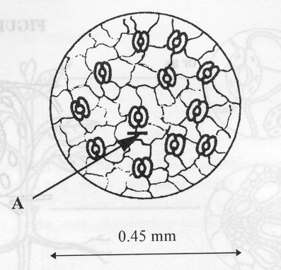

- The diameter of the field of view at 400x is 0.45 mm. Calculate the width, indicated by the bar (A), of the structure shown on the diagram.

__________________________________________________________________
(2 marks)

- Name the specialised structures present in the leaf epidermis.

_____________________________________________________________________
(1 mark)
- Explain the role they play in terms of gas exchange

(3 marks)

- Explain in detail how the structures are able to open and close.

(3 marks)

- List four characteristic of an efficient respiratory system and explain their importance.

(8 marks)

- Name the structure in vascular plants for transporting water and explain how these vessels are adapted to enhance this function.

(3 marks)

